What is the Diversity Visa Lottery?
The Diversity Immigrant Visa program—a.k.a. the green card lottery—is a government lottery program for obtaining U.S. Permanent Residence (green card). The program makes 50,000 visas available every year to applicants from countries with low rates of immigration to the United States and with specific education qualifications. It provides an inexpensive and relatively simple path to a green card, without needing sponsorship from a U.S. employer or family.

Who Can Apply?
To be eligible for the Diversity Immigrant Visa Program, you, your spouse, or your parent must have been born in a country that sent less than 50,000 immigrants to the United States in the previous five years. DOS publishes a full list of the eligible countries on its website.

For the 2025 program, the following countries are not eligible to apply due to high rates of immigration to the United States:

Bangladesh Brazil Canada
China, including Hong Kong SAR (Natives of Macau SAR and Taiwan are eligible)
Colombia Dominican Republic El Salvador
Haiti Honduras India
Jamaica Mexico Nigeria Pakistan Philippines
Republic of Korea (South Korea)
Venezuela
Vietnam

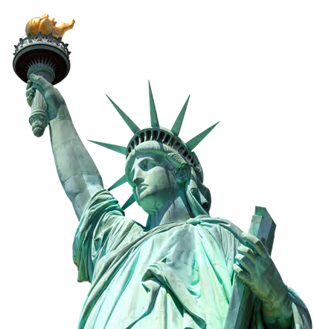
NOT ELIGIBLE COUNTRIES
#AILAStandsWithImmigrants
THE FISCAL YEAR 2025 U.S DIVERSITY
VISA LOTTERY IS NOW OPEN
©2023 American Immigration Lawyers Association
#AILAStandsWithImmigrants
AILA is the national bar association of immigration lawyers comprised of over 15,000 members located in every state of the United States and worldwide.
In addition to the nationality requirements, applicants must possess at least a high school diploma or its equivalent; or
two years of work experience in an occupation that requires at least two years of training or experience. DOS publishes a list of occupations that are eligible on their website.

Non-U.S. residents seeking to obtain a green card from an eligible country may apply regardless of whether they live in the United States or abroad. This includes foreign workers who are waiting to obtain a green card through the labor certification program.

When Can I Apply?
The entry submission period for the FY2025 Diversity Immigrant Visa program is from 12:00 pm (ET) on October 4, 2023, to 12:00 pm (ET) on November 7, 2023. The entry form will only be available for submission during this period. In years past, the last week of the registration period saw heavy demand on DOS’s application website, causing website delays. Therefore, submitting your application as early as possible is encouraged. The results of the DV-2025 lottery will be available on the E-DV site as of May 4, 2024.

How Do I Apply?
Entries must be submitted online through DOS’s website. Paper entries are not accepted. Online applications are free, but visa processing fees may apply if selected. DOS releases detailed instructions on their website , which can be found here:
https://travel.state.gov/content/travel/en/us-visas/immigrate/diversity-visa-program-entry/diversity-visa-instructions.html

If you want to learn more about the U.S. Diversity Visa Lottery, do not hesitate to contact Tidwell, Swaim & Farquhar at 972-385-7900.

